DESIGN AND ANALYSIS OF ALGORITHMS LAB WORKBOOK

WEEK ­ 4

NAME : HARISH R
ROLL NUMBER : CH.SC.U4CSE24163 CLASS : CSE-B

MERGE SORT
CODE:
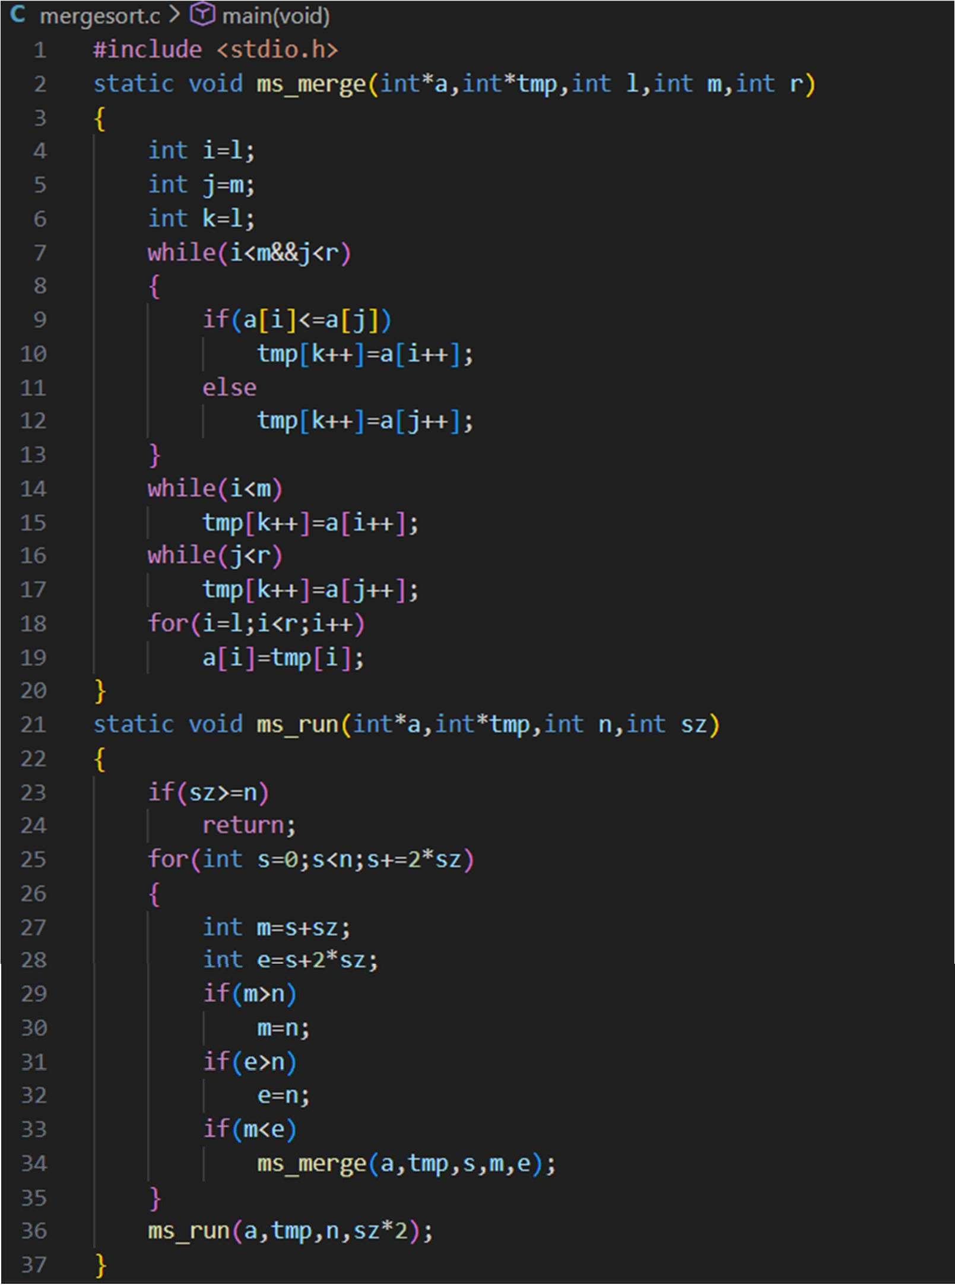

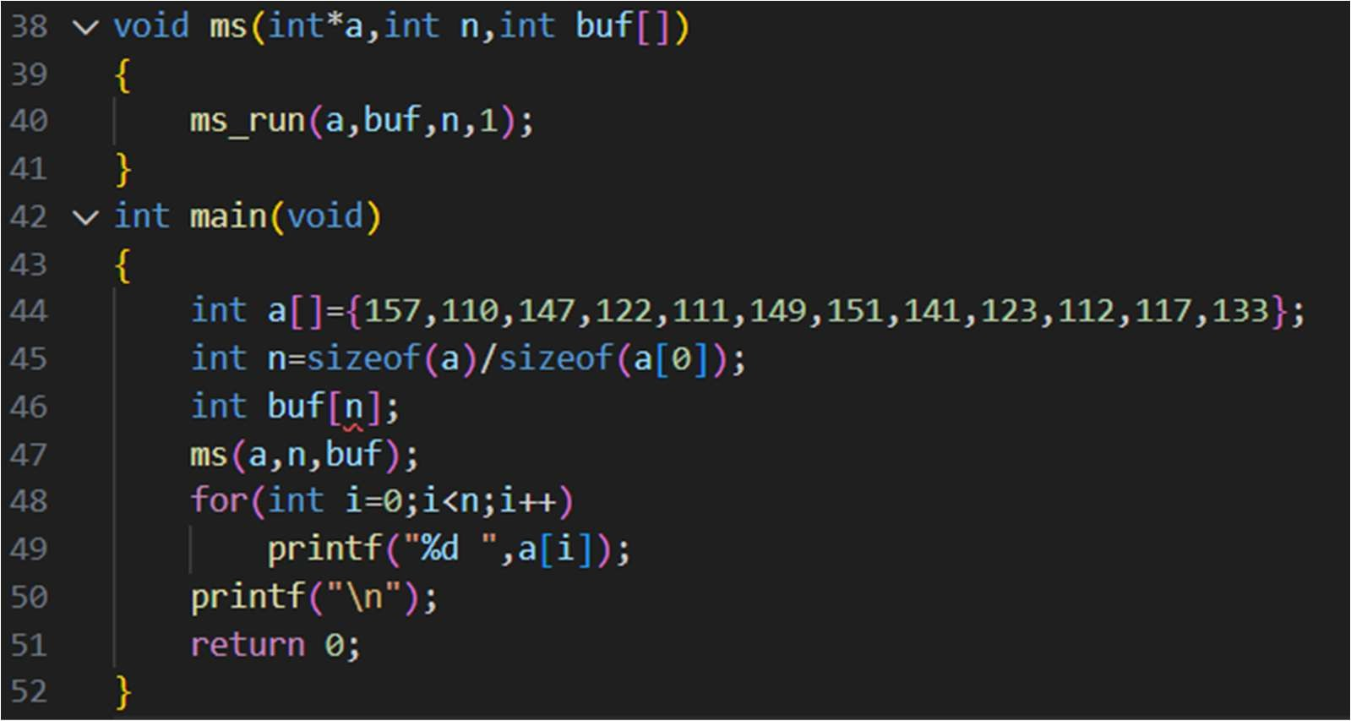

OUTPUT:

Space Complexity: O(N) Time Complexity: O(N log N) Justification:
- The array is divided into two equal halves at each step, and the merge operation compares all n elements. Since this division continues for log n levels, the overall Time Complexity becomes O(N log N).
- An extra array is used during the merging process to temporarily store elements. This additional storage requires space proportional to the number of elements, resulting in O(n) Space Complexity.

QUICK SORT
CODE:
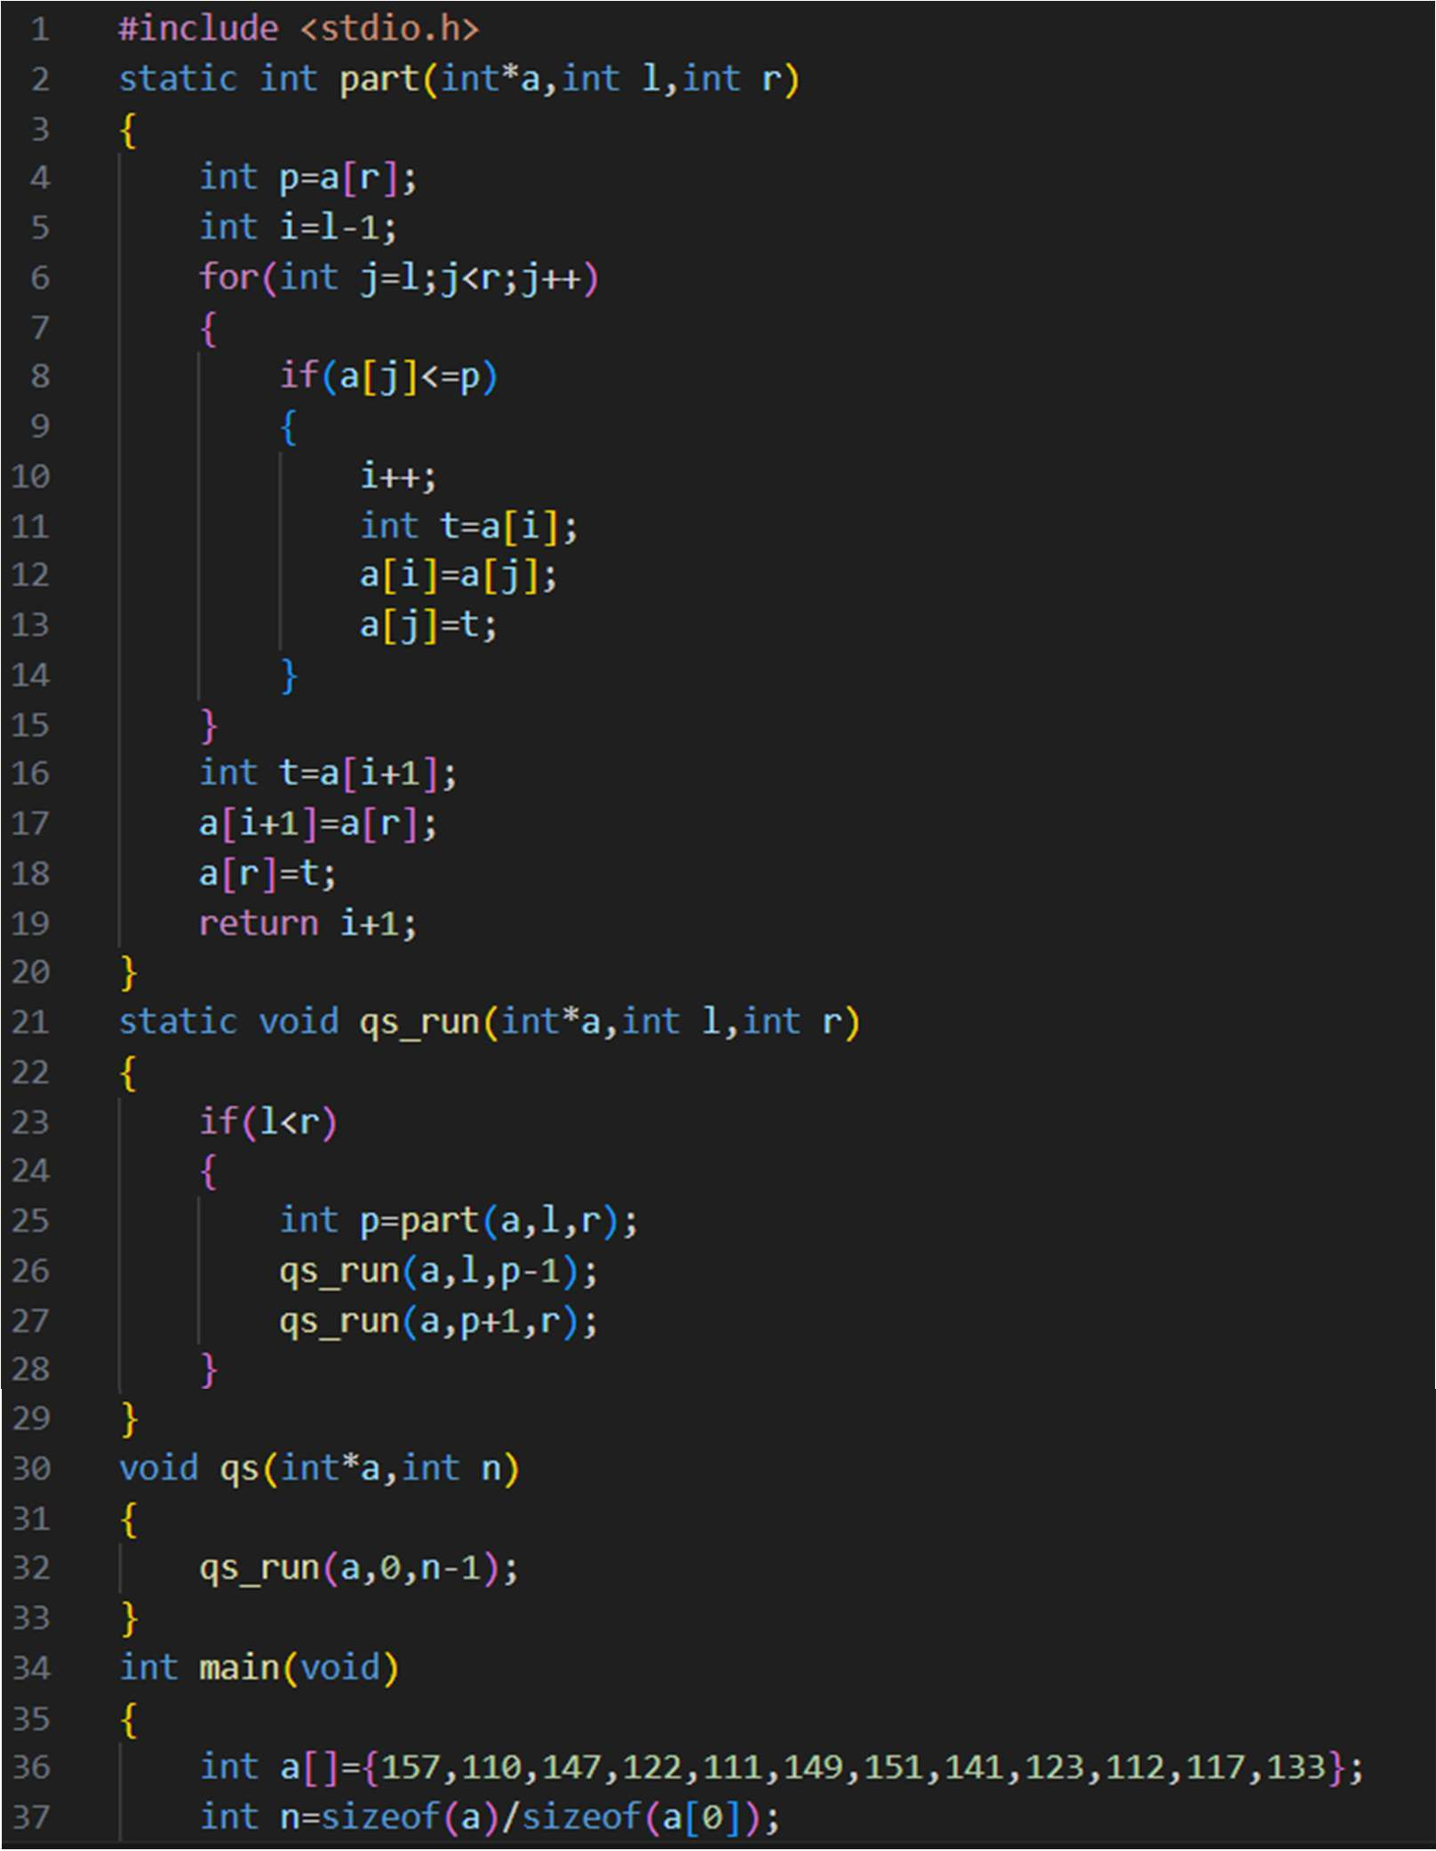

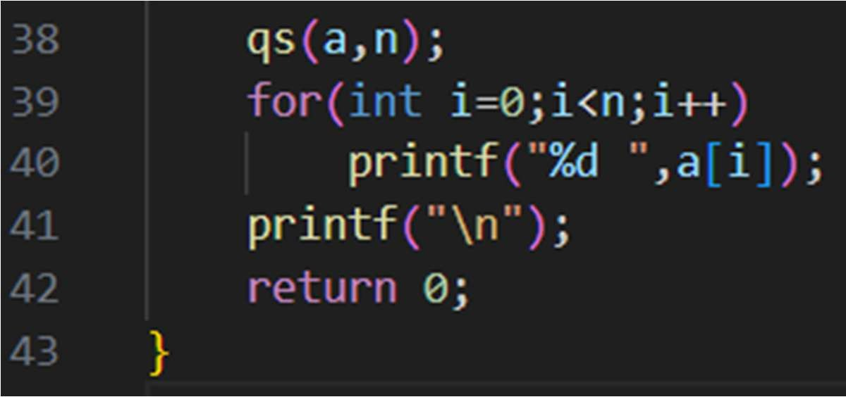

OUTPUT:


Space Complexity: O(N) Time Complexity: O(N^2) Justification:
- In the worst case, Quick Sort makes highly unbalanced recursive calls, reducing the problem size by only one element at each step. As a result, the recursion depth becomes n, and the recursion stack stores up to n function calls, leading to O(N) Space Complexity.

- This occurs when the pivot divides the array into highly unbalanced parts, such as in already sorted or reverse sorted array. Hence the Time Complexity is O(N^2).

